For Registrar’s Use only
Code # HSS01
New Minor Proposal-Bulletin Change Transmittal Form
☐ Undergraduate Curriculum Council - Print 1 copy for signatures and save 1 electronic copy.
New Certificate or Degree Program (The following critical elements are taken directly from the Arkansas Department of Higher Education’s “Criteria and Procedures for Preparing Proposals for New Programs”.) Please complete the following and attach a copy of the catalogue page(s) showing what changes are necessary.

___________________ Enter date…  Department Curriculum Committee Chair | ___________________ Enter date…  COPE Chair (if applicable)
___________________ Enter date…  Department Chair: | ___________________ Enter date…  General Education Committee Chair (If applicable)
___________________ Enter date…  College Curriculum Committee Chair | ___________________ Enter date…  Undergraduate Curriculum Council Chair
___________________ Enter date…  College Dean | ___________________ Enter date…  Graduate Curriculum Committee Chair
___________________ Enter date…
Vice Chancellor for Academic Affairs

1. Proposed Program Title
Minor in Writing Studies

2. CIP Code Requested
23.13

3. Contact Person (Name, Email Address, Phone Number)
Dr. Kristi Costello, kcostello@astate.edu, 870 972 3043

4. Proposed Starting Date
8/15/2014

From the most current electronic version of the bulletin, copy all bulletin pages that this proposal affects and paste it to the end of this proposal.
To copy from the bulletin:
- Minimize this form.
- Go to http://registrar.astate.edu/bulletin.htm and choose either undergraduate or graduate.
- This will take you to a list of the bulletins by year, please open the most current bulletin.
- Find the page(s) you wish to copy, click on the “select” button and highlight the pages you want to copy.
- Right-click on the highlighted area.
- Click on “copy”.
- Minimize the bulletin and maximize this page.
- Right-click immediately below this area and choose “paste”.
- For additions to the bulletin, please change font color and make the font size larger than the surrounding text. Make it noticeable.
- For deletions, strike through the text, change the font color, and enlarge the font size. Make it noticeable.

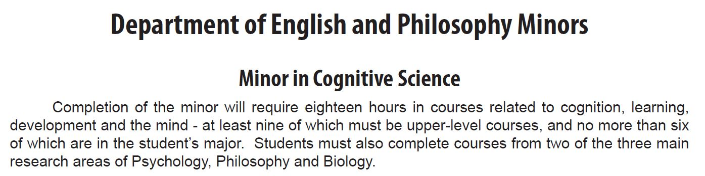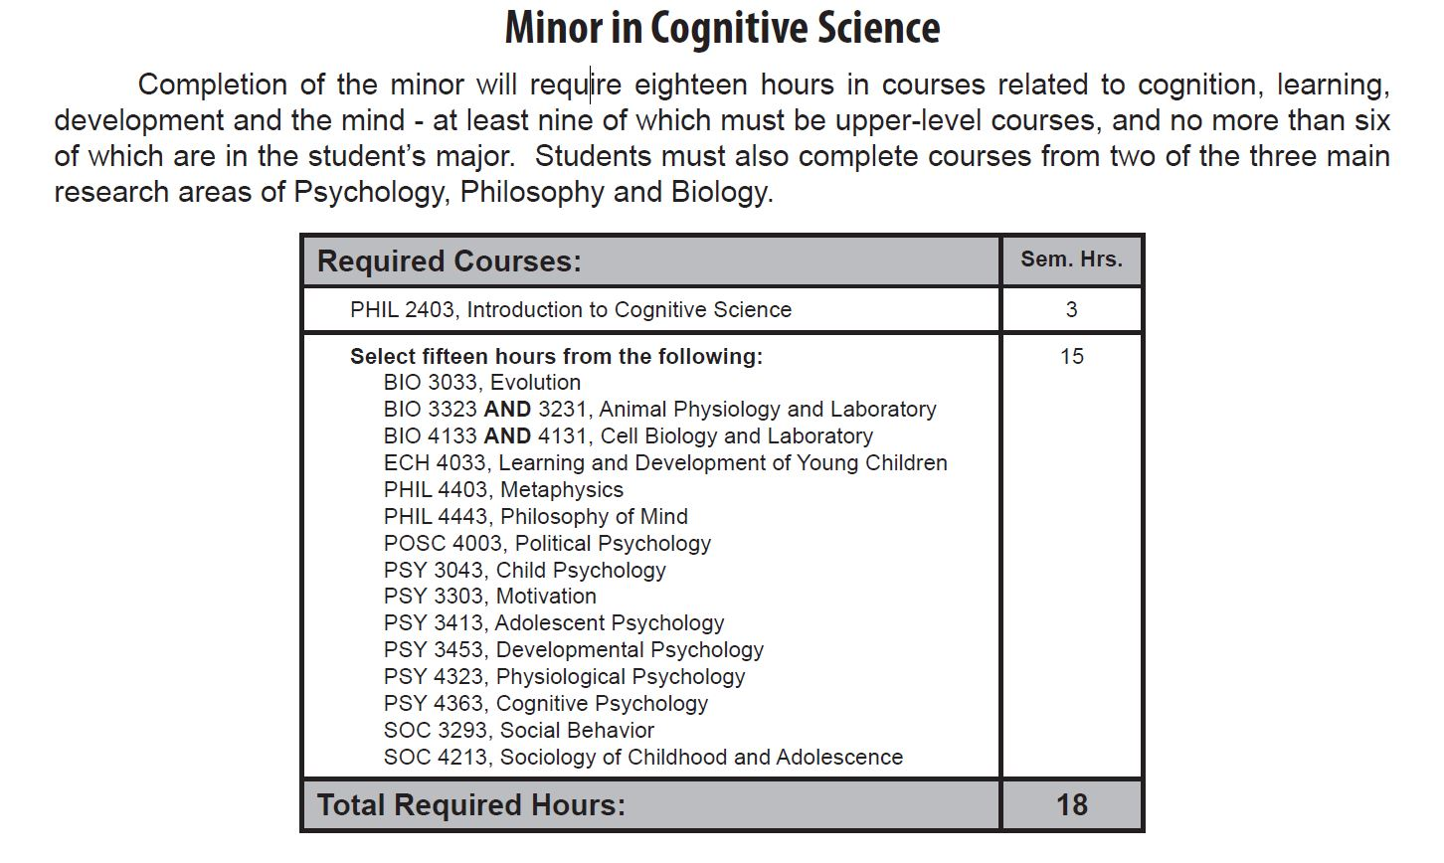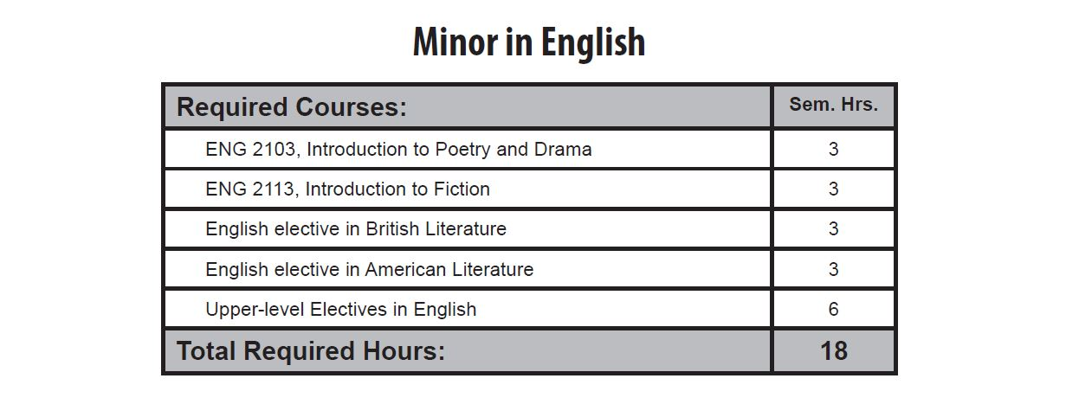

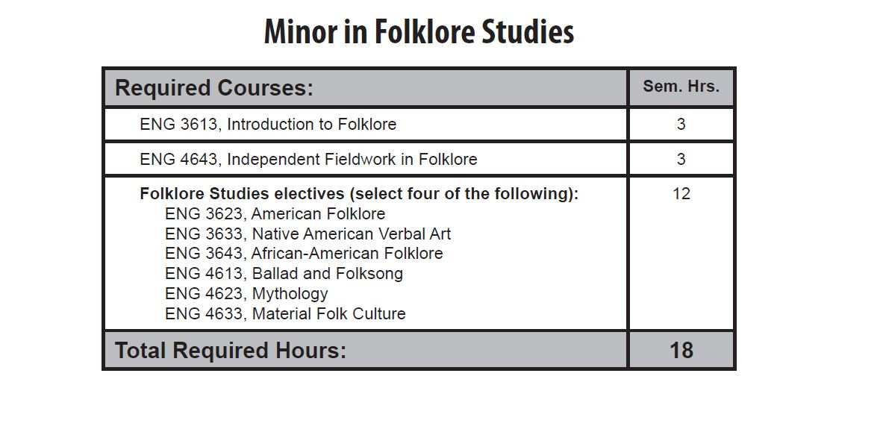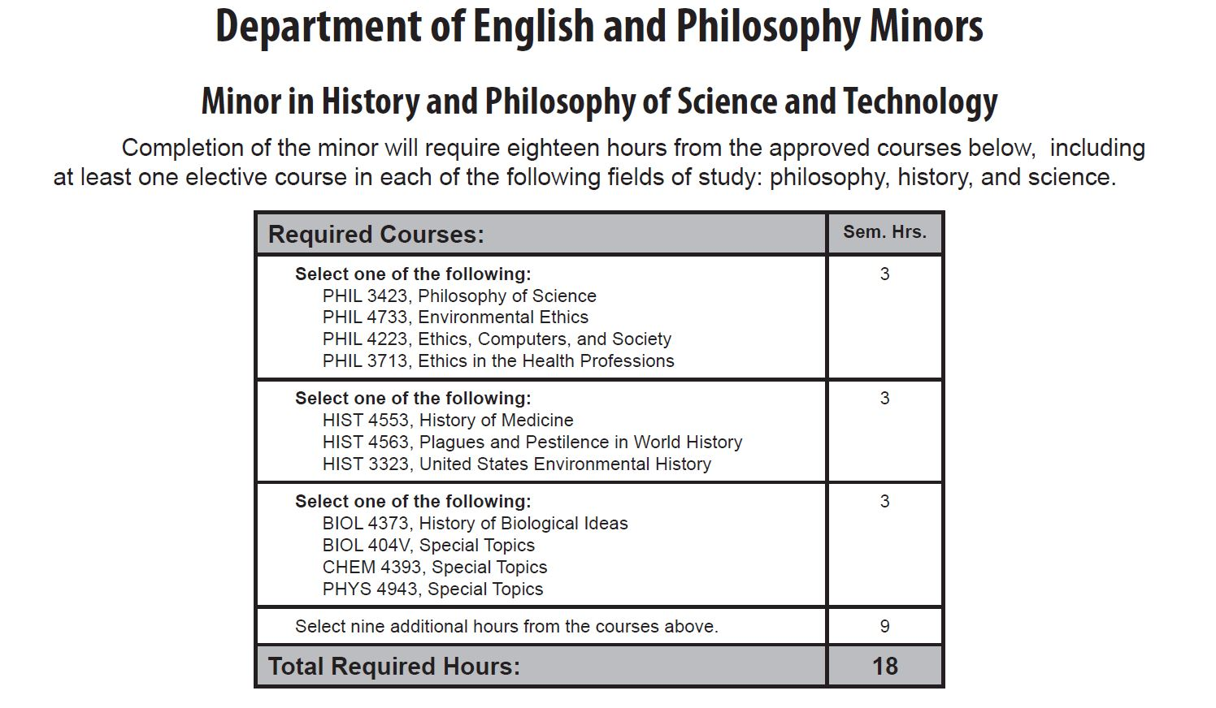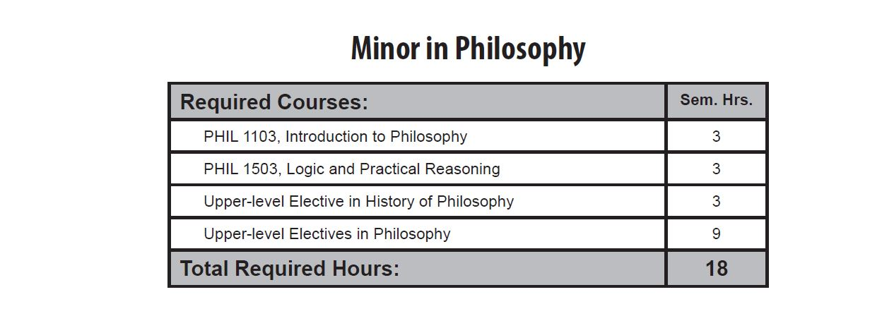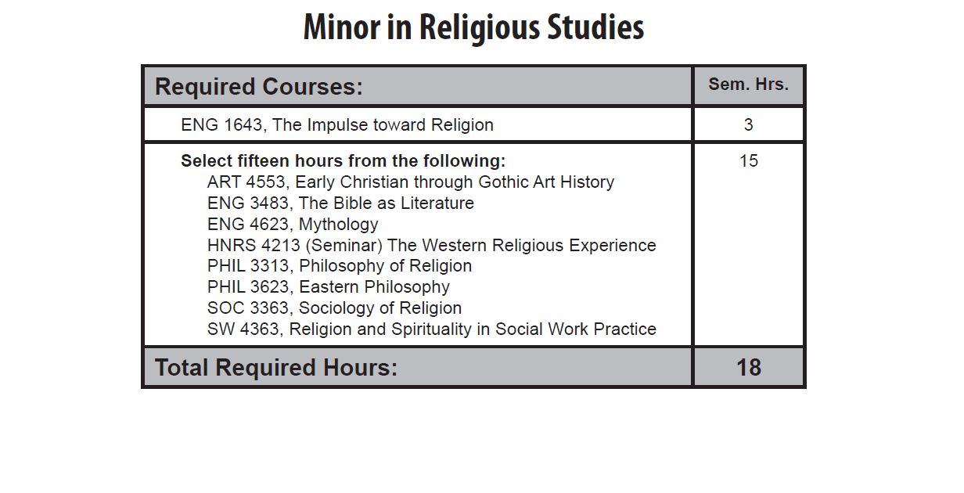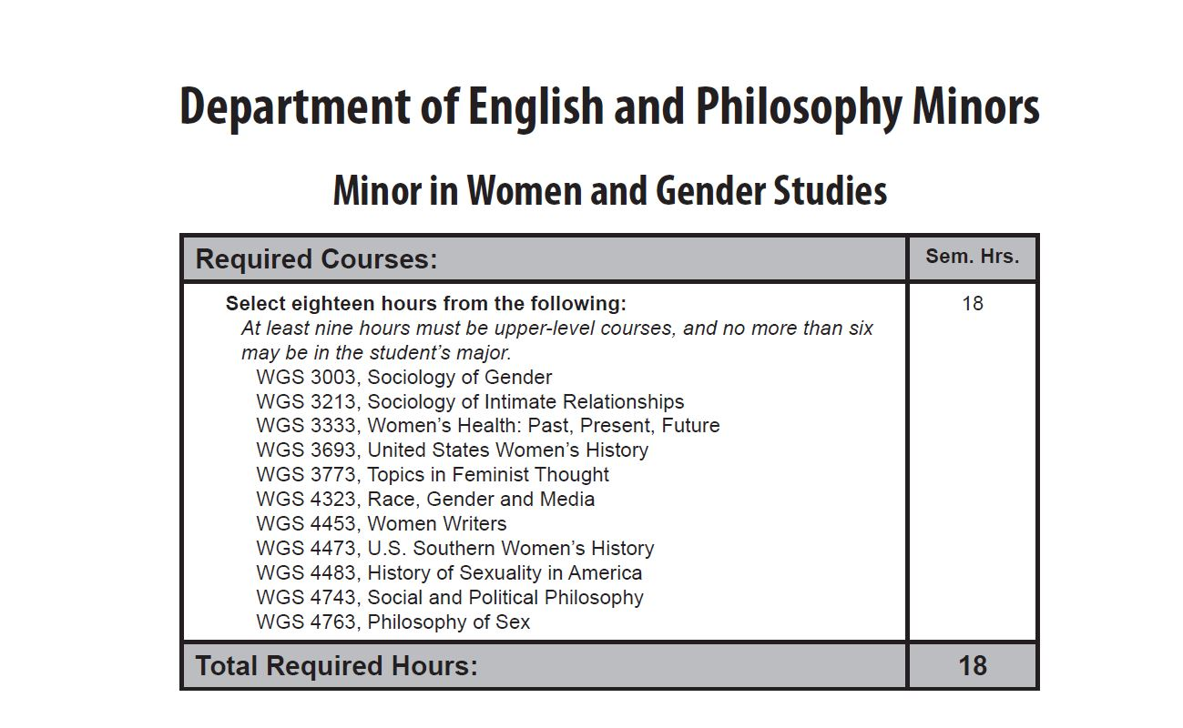

Minor in Writing Studies
Minor in Writing Studies, General Track
Required Courses: Sem. Hrs.
ENG 3033 Introduction to Writing Studies 3
Elective from Professional Writing Track 3
(ENG 3003, ENG 3013, ENG 3043,
ENG 4703, ENG 3053)
Elective from Creative Writing Track 3
(ENG 3023, ENG 4023, THEA 4313, CMP 3403)
ENG 4711 Preceptorship in Writing Studies* 1
ENG 4722 Internship in Writing Studies* 2
Electives in Writing Studies 6
_______
18

Minor in Writing Studies, Creative Writing Track
Required Courses: Sem. Hrs.
ENG 3033 Introduction to Writing Studies 3
ENG 3023 Creative Writing and ENG 4023 Advanced 9
Creative Writing (courses may be repeated for Fiction, Poetry,
Creative Non-Fiction, etc.; may include either
THEA 4313 Fundamentals of Playwriting* or CMP 3403 Screenwriting for Narrative Motion Pictures*)
ENG 4711 Preceptorship in Writing Studies* 1
ENG 4722 Internship in Writing Studies* 2
Elective in Writing Studies 3
_______
18

Minor in Writing Studies, Professional Writing Track
Required Courses: Sem. Hrs.
ENG 3033 Introduction to Writing Studies 3
ENG 3043 Technical Writing 3
ENG 3013 Practical Writing 3
ENG 3003 Advanced Composition 3
ENG 4711 Preceptorship in Writing Studies* 1
ENG 4722 Internship in Writing Studies* 2
Elective in Writing Studies 3
_________
18

* For BSE students only, EDEN 4553 Methods and Materials for Teaching English in the Secondary School may substitute for the Preceptorship and Internship. THEA 4313 and CMP 3403 cannot be used by students majoring in the College of Media & Communication to fulfill this minor.

In Addition, in Undergraduate Bulletin 2013-2014 where ENG courses appear (pp. 466ff), the following changes:

ENG 0203. Composition for Non-Native Speakers II Designed to help non-native students develop their ideas into well organized, well developed and effective paragraphs and essays based on major rhetorical patterns. Grammar, sentence structure, and the complete writing process are emphasized. The grade in this course will not be used to compute semester and cumulative grade point averages. The course does not count toward any degree. Fall, Spring.
ENG 1003. Composition I Study and practice of fundamentals of written communication including principles of grammar, punctuation, spelling, organization, and careful analytical reading. Prerequisite, with grade of C or better, for ENG 1013. Fall, Spring. (ACTS#: ENGL 1013)
ENG 1013. Composition II Continues the practice of ENG 1003, to develop further the skills learned in that course. Based on reading and discussion of various types of writing, the students’ essays will provide practice in different kinds of rhetorical development including research and documentation. Prerequisite, must complete ENG 1003 with grade of C or better for degree. Fall, Spring. (ACTS#: ENGL 1023)
ENG 1023. Making Connections Humanities Required course for first semester freshmen. Core content includes transition to college, academic performance skills, problem solving, critical thinking, self management, group building skills, and university policies. Content related to the departmental majors is also included. Fall.
ENG 1643. The Impulse toward Religion Demonstrates why and how religious belief and expression, though different in various cultures, remain vital forces. Required course for minor in Religious Studies. Fall.
ENG 2003. Introduction to World Literature I Introduction to the analysis and interpretation of literary works from several historical periods ranging from early civilizations through the Renaissance. Fall, Spring. (ACTS#: ENGL 2213)
ENG 2013. Introduction to World Literature II Introduction to the analysis and interpretation of literary works from several historical periods ranging from the Renaissance to the present. Fall, Spring. (ACTS#: ENGL 2223)
ENG 2103. Introduction to Poetry and Drama Poetry and drama with emphasis on analytic reading and writing skills. Fall, Spring.
ENG 2113. Introduction to Fiction Short fiction and the novel with emphasis on analytic reading and writing skills. Fall, Spring.
ENG 3003. Advanced Composition Emphasis on the development of structure and style in the literary essay and on research skills. Spring.
ENG 3013. Practical Writing Emphasis on practical writing skills applicable to students in all disciplines. Will not apply to English degree requirements. Fall, Spring.
ENG 3023. Creative Writing Instruction and practice in the writing of poetry, fiction, and drama. May be repeated with change of literary category. Fall.
ENG 3033. Introduction to Writing Studies Inquiry and practice in the theory, ideology, and ethics of writing in private, public, professional, technological, and academic contexts. Spring.
ENG 3043. Technical Writing Forms and techniques of technical writing. Will not apply to English BA major requirements. Spring, odd.
ENG 3053. Introduction to Digital Writing Introduction to digital writing with analysis of how multiple modes work together to create meaning in digital spaces. Students will produce digital texts with attention to genre, media, purpose, and audience. Prerequistes, ENG 1003 and ENG 1013. Spring, even.

ENG 3223. British Literature to 1800 Major British authors, genres, and movements from the beginning to the end of the Neoclassical period. Fall, even.
ENG 3233. Shakespeare Introduction to the works of Shakespeare. Fall.
ENG 3243. British Drama to 1800 Drama in the Middle Ages, Renaissance, Restoration, and Neoclassical periods, including at least three Shakespeare plays. Spring, odd.
ENG 3263. British Literature Since 1800 Major British authors, genres, and movements from the Romantic period to the present. Fall, odd.
ENG 3293. British Novel Representative British novels. Spring, even.
ENG 3323. American Literature to 1865 Major American authors, genres, and movements from the beginning to the end of the Neoclassical period. Fall, even
ENG 3363. American Literature Since 1865 Major American authors, genres, and movements from the Civil War to the present. Fall, odd.
ENG 3373. Regional American Literature Writings from a selected region of the United States. Fall, odd.
ENG 3393. American Novel Representative American novels. Spring, odd.
ENG 3453. World Literature Selected authors, genres, movements, or themes in world literature. Fall, even.
ENG 3463. Literature and Film A study of how literature and literary tradition translate into cinema. Prerequisites, ENG 2003, 2013, 2103, 2113 or equivalent. Fall, even.
ENG 3473. Contemporary Literature Global literature mainly from 1945 to the present, including British, American, and world authors. May focus on poetry, prose, or drama,or a combination of those. Fall.
ENG 3482. Special Projects Practicum in the teaching of composition for the preprofessional. Prerequisite, consent of instructor. Fall.
ENG 3483. The Bible as Literature Analytical and critical study of selected books of the Bible with emphasis on its component genres, literary qualities, and influence. May not be repeated for credit. Spring, odd.
ENG 3493. Popular Literature One or more selected topics of popular literature, for example, science fiction, fantasy, sport, detective fiction, and the best seller. Spring, even.
ENG 3583. Literature for Adolescents Fiction, poetry, and drama which meet the needs of upper elementary, middle school, and high school students. Fall.
ENG 3613. Introduction to Folklore Collection, classification, and analysis of folklore, with special emphasis on oral literature. Fall.
ENG 3623. American Folklore Survey of the unofficial culture which has helped to shape the American experience, with special emphasis on oral literature, conventional belief, and traditional lifeways. Spring, odd.
ENG 3633. Native American Verbal Art Examination of oral literature of the indigenous peoples of North America and of contemporary literature written by American Indians. Spring, even.
ENG 3643. African-American Folklore A study of African American culture through New World black traditions, including oral narratives and folksongs. Spring, even.
ENG 4023. Advanced Creative Writing Writing poetry, fiction, or drama. Prerequisite, ENG 3023 or permission of instructor. May be repeated with change of literary category. Spring.
ENG 4043. Theory in the Teaching of Composition An introduction to teaching composition based on current research and theory with special emphasis on practical applications in the secondary school classroom. Spring.
ENG 4053. The English Language Historical, structural, and linguistic development of the English language, emphasizing sound change and analysis of spoken and written English. Fall, even
.
ENG 4063. Comparative Modern Grammars Major grammatical systems, traditional, structural,and transformational. Spring.

ENG 4083. Introduction to Linguistics Phonetics, phonemics, morphology, syntax, and semantics. Fall, odd.

ENG 4103. Introduction to Contemporary Literary Theory An introduction to the major theoretical approaches to literary criticism, ranging from formalism through poststructuralism. Fall, odd.

ENG 4113. Genre Studies: Tragedy, Comedy, Romance or Epic Studies in one of four genres in all its formal aspects and changing manifestations in literature, including fiction, drama, and poetry. Spring, odd.

ENG 4183. Renaissance Drama Excluding Shakespeare Familiarizes the student with the contemporaries of Shakespeare in the Elizabethan and Jacobean theatre. Some familiarity with Shakespeare helpful, but not essential. Spring, even.
ENG 4213. Medieval Literature English literature during the Middle Ages. Selected continental writings may be included. Spring, odd.
ENG 4223. Milton An intensive study of selected works of John Milton. Fall, odd.
ENG 4233. Sixteenth-Century Literature English literature during the sixteenth century. Selected continental writings may be included. Spring, even.
ENG 4243. Seventeenth-Century Literature English literature during the seventeenth century. Selected continental writings may be included. Fall, even.
ENG 4253. Restoration and Neoclassical Literature English literature during the late seventeenth and eighteenth centuries. Selected continental writings may be included. Spring, even.
ENG 4263. Romantic Literature Major currents and figures of the English Romantic movement. Selected background writings may be included. Fall, even.
ENG 4273. Victorian Literature Major currents and figures in the Victorian Age. Selected background writings may be included. Spring, odd.
ENG 4283. Modern British Literature English literature in the twentieth century. Selected background writings may be included. Fall, odd.
ENG 4333. American Romanticism American literature in the first half of the nineteenth century. Spring, odd.
ENG 4353. American Realism and Naturalism American literature in the second half of the nineteenth century and the early twentieth century. Spring, even.
ENG 4363. African-American Literature Survey of African American literature from its beginnings to the present. Spring, odd.
ENG 4373. Modern American Literature American literature since World War I. Spring, even.
ENG 4383. Minority Literature Selected works of American minority writers from such groups as Blacks, Native Americans, or Chicanos. Fall, even.
ENG 4453. Women Writers A study of literature written by women. Cross listed as WGS 4453. Spring, odd.
ENG 4463. Special Topics Intensive study of individual authors, limited periods, movements, or specific theme. Demand.
ENG 4473. Special Topics in Writing Studies Intensive study of a topic, issue, or theory in the field of Writing Studies. May be repeated up to six hours when topic changes. Prerequisite, ENG 3033 or permission of the instructor. Fall, odd.
ENG 4613. Ballad and Folksong Analysis and interpretation of oral poetry, especially that of the English speaking world. Fall, odd.
ENG 4623. Mythology Content, structure, and belief systems of various mythologies from the perspectives of selected mythographers. Spring, odd.
ENG 4633. Material Folk Culture The analysis and interpretation of traditional skills, services, and art and craft objects provided in folk societies. Fall, even.
ENG 4643. Independent Fieldwork in Folklore Development and implementation of a research agenda, using standard field methods in folklore studies such as the tape-recorded interview and participant observation. Prerequisites, ENG 3613 and permission of instructor. Fall, Spring.
ENG 4703. Persuasive Writing Practice in reading and writing persuasive texts, with study of theories relating to rhetoric and persuasion. Fall.

ENG 4711. Preceptorship in Writing Studies Professional and pedagogical practices in the field of Writing Studies. Prerequisite, ENG 3033 and three more hours of courses applicable to the Writing Studies minor with grade of C or better. Fall.

ENG 4722. Internship in Writing Studies Supervised work in an approved professional setting. Prerequisite, six hours of courses applicable to the Writing Studies minor with grade of C or better and prerequisite or corequisite, ENG 4711. Fall.

ENG 4733. Advanced Internship in Writing Studies Supervised work in an approved professional setting. Prerequisite, ENG 4722. Spring.

LETTER OF NOTIFICATION
NEW MINOR
(Maximum 18 semester credit hours of new theory courses and 6 credit hours of new practicum courses)

1. Institution submitting request:
Arkansas State University

2. Contact person/title:
Dr. Kristi Costello, Ph.D., Director of ASU Writing Studies Program

3. Phone number/e-mail address:
870 972 3043, kcostello@astate.edu

4. Proposed effective date:
8/15/2014

5. Title of minor:
Minor in Writing Studies (3 Tracks: General Track, Creative Writing Track, or Professional Writing Track)

6. Reason for proposed action:
To improve writing instruction and writing on campus. Increased professionalization and marketability of students from a variety of fields.

7. New minor objective:
1) Familiarize students with the guiding research, theories, genres, and practices in the field of Writing Studies. 2) Provide students with relevant professional experiences.

8. Provide the following:
a. Curriculum outline - List of required courses
See attached.

b. New course descriptions
ENG 3033. Introduction to Writing Studies Inquiry and practice in the theory, ideology, and ethics of writing in private, public, professional, technological, and academic contexts. Spring.
ENG 3053. Introduction to Digital Writing Introduction to digital writing with analysis of how multiple modes work together to create meaning in digital spaces. Students will produce digital texts with attention to genre, media, purpose, and audience. Spring, even. ENG 4473. Special topics in Writing Studies Intensive study of a topic, issue, or theory in the field of Writing Studies. May be repeated up to six hours when topic changes. Fall, odd.
ENG 4711. Preceptorship in Writing Studies Professional and pedagogical practices in the field of Writing Studies. Prerequisite, ENG 3033 and three more hours of courses applicable to the Writing Studies minor with grade of C or better. Fall.
ENG 4722. Internship in Writing Studies Supervised work in an approved professional setting. Prerequisite, six hours of courses applicable to the Writing Studies minor with grade of C or better and prerequisite or corequisite, ENG 4711. Fall.
ENG 4733. Advanced Internship in Writing Studies Supervised work in an approved professional setting. Prerequisite, ENG 4722. Spring

c. Program goals and objectives
Goal 1: Familiarize students with the guiding research, theories, genres, and practices in the field of Writing Studies. Goal 2: Provide students with relevant professional experiences.

d. Expected student learning outcomes
SLO’s for Goal 1: a. Understand writing as a recursive process. b. Analyze their own and peers’ writing and offer meaningful suggestions for revision. c. Produce writing in multiple genres for various audiences.

9. Will the new option be offered via distance delivery?
No

10. Mode of delivery to be used:
Lecture, preceptorship, internship

11. Explain in detail the distance delivery procedures to be used:
An occasional course may be available online that would apply to this course.

12. List courses in minor. Include course descriptions for new courses:
See attached.

13. Specify the amount of the additional costs required, the source of funds, and how funds will be used.
$0.00

President/Chancellor Approval Date: Enter date... | ___________________ Enter date…  Vice Chancellor for Academic Affairs
Board of Trustees Notification Date: Enter date...

